***Chapter 1***

**INTRODUCTION**

### Introduction

The purpose of this development is to limit the wastage of food in the Society. Many restaurants and people tend to throw the leftover food at the end of the day even though the food is perfectly fine to be eaten, which means that huge amounts of food is wasted. While all that food is being wasted, some families can barely afford proper meals with their limited money. They don't get enough nutrition due to the lack of having three meals in a day. Therefore, we decided to create our application to link the restaurant and people with the unfortunate people, so instead of throwing the food, the unfortunate will be able to pick it up from the restaurant and the people at the end of the day. The application allows the restaurants and people to log in, and upload an image of the meals they have as leftovers along with a description of that meal, and the location where to pick it up.

* 1. **Problem Statement**

The problem statement highlights the prevalent issue of food wastage in contemporary society. In the present day, the squandering of food has become a pervasive problem with significant societal implications. This issue extends beyond individual behavior and necessitates a systematic approach to mitigate its adverse effects. Food waste management emerges as a critical aspect of this solution, holding the potential to positively impact both the environment and economic sustainability.

In response to this challenge, the proposed initiative involves the development of a website designed to address and overcome the issue of food waste. The website serves as a platform for connecting food donors with those in need. Key to its functionality is the retrieval of donor information, including their location. This information is crucial for facilitating a seamless process wherein individuals seeking food assistance can log into their accounts and efficiently locate available food resources in their vicinity.

By leveraging technology and an online platform, the project aims to streamline the process of food donation and distribution. The integration of donor information and location data enhances the accessibility and efficiency of the system, ensuring that surplus food reaches those who require it. This initiative not only addresses the immediate problem of food waste but also establishes a practical solution that promotes community engagement and responsible resource utilization. Ultimately, the website becomes a tool for fostering a more sustainable and compassionate approach to food consumption and distribution in our society.

### 1.3 Existing System

Many restaurants and people tend to throw the leftover food at the end of the day even though the food is perfectly fine to be eaten, which means that huge amounts of food are wasted. While all that food is being wasted, some families can barely afford proper meals with their limited money. They don't get enough nutrition due to the lack of having three meals in a day.

Therefore, we decided to create our application to link the restaurant and people with the unfortunate people, so instead of throwing the food, the unfortunate will be able to pick it up from the restaurant at the end of the day.

### 1.4 Disadvantages

The following are the disadvantages of the existing system

* As there are many people who are waiting for food all them will not get the food.
* Need proper internet connection.

### 1.5 Proposed System

Web application technology is beneficial for food waste management. The website aims to encourage better food management. Our proposed solution should reduce food wastage by facilitating food sharing in India community using web technology. This work is an initial step towards designing a better system to reduce daily food waste. In future, this website could be enhanced more by adding the following features:

• Extending our website to have many types of donating users either from organizations such as restaurants, or a family or a single user

• Adding the location facility to our website. The donating user should specify the location of the shared food.

• Adding the time and date of each meal shared by users

• Making the website supports multiple platforms (crossplatform app) .

**1.6 Advantages**

The proposed website offers several key advantages:

The primary objective of the website is to extend a helping hand to individuals facing food insecurity. By connecting food donors with those in need, the platform facilitates a direct and efficient way to address immediate hunger and nutritional deficiencies in the community.

A significant benefit of the website is its potential to substantially decrease the wastage of food. By creating a streamlined process for donors to share surplus food with those who require it, the initiative actively contributes to minimizing unnecessary food disposal and, in turn, promotes a more sustainable and responsible approach to resource utilization.

The simplicity of use is a key feature of the website. Designed with user accessibility in mind, the platform ensures that both donors and recipients can easily navigate through the system. This user-friendly interface contributes to the efficiency of the initiative, making it inclusive and accessible to a broader audience.

The incorporation of a map feature in the website enhances the tracking and management of food distribution. Donors and recipients can visualize and pinpoint locations with ease, ensuring a transparent and accountable process. This mapping functionality not only simplifies logistics but also fosters trust and reliability within the community.

In summary, the website emerges as a valuable tool that not only provides immediate assistance to individuals facing food insecurity but also contributes significantly to the broader societal goal of reducing food wastage. Its simplicity, tracking features, and dual impact make it a practical and impactful solution in the effort to create a more sustainable and compassionate community.

***Chapter 2***

**REQUIREMENT ANALYSIS**

Requirement analysis is a critical phase in the development of a food donation website, as it lays the foundation for the entire project by identifying the key functionalities and features that will meet the needs of both donors and recipients.

The first and foremost requirement is an intuitive user interface that ensures ease of use for individuals with varying levels of technological proficiency. This includes a straightforward registration process for both donors and recipients, allowing them to easily create and manage their profiles. The user interface should be designed to facilitate efficient navigation, making it simple for users to browse and contribute to the platform.

Security is paramount in a food donation website, considering the sensitive nature of personal information and the need to protect against potential misuse. The platform should implement robust data encryption protocols and incorporate secure payment gateways if financial transactions are involved. Additionally, user authentication and authorization mechanisms should be in place to ensure that only authorized users have access to certain functionalities.

For donors, the website should provide a clear and comprehensive listing of accepted food items and guidelines for donation. The donation process itself should be streamlined, allowing donors to easily schedule pickups or drop-offs and receive confirmation notifications. A tracking system could also be implemented to keep donors informed about the status of their contributions.

On the recipient side, the website must efficiently match available food donations with the needs of various organizations and individuals. This requires the incorporation of a smart algorithm or matching system that takes into account factors such as location, dietary restrictions, and urgency. Notifications and communication features are also essential to keep recipients informed about incoming donations and to facilitate coordination.

To enhance community engagement, the website could include social sharing features, allowing users to spread awareness about the platform and their contributions. Integration with social media platforms can further amplify the impact of the website and encourage a broader audience to participate in the initiative.

Regular updates and maintenance are crucial to ensure the website's continued effectiveness. This involves monitoring user feedback, addressing any issues promptly, and implementing periodic updates to enhance features or introduce new functionalities based on evolving needs.

In conclusion, a successful food donation website requires a comprehensive requirement analysis to address user needs, security concerns, and community engagement. Through a well-defined set of features and functionalities, the website can serve as a robust platform for facilitating food donations and making a positive impact on communities in need.

**2.1 Functional Requirements**

Functional requirements are essential components that delineate the specific functionalities and operations that a system must perform to meet user needs. In the context of a food ordering system, these requirements encompass various aspects that contribute to the system's seamless operation.

One fundamental functional requirement involves the ability for users to enter their mail-id and password to initiate a secure sign-in process. This ensures that the system authenticates users and provides access to personalized features and information.

The next crucial step is the capability to search for food items within the system. This functionality enhances user experience by allowing them to efficiently browse through available options, making the selection process more convenient and tailored to individual preferences.

Once users have identified their desired items, the system should enable them to add these selections to a virtual shopping cart. This feature is integral to the e-commerce aspect of a food ordering system, facilitating a streamlined and organized approach to managing chosen items before finalizing the order.

Placing an order is a pivotal functional requirement, and the system should support a user-friendly process for users to confirm and complete their purchase. This involves providing necessary details for delivery, ensuring a smooth transaction, and generating a confirmation for the user's records.

To maintain an up-to-date database of food items, a system should include functionality for administrators to update food details. This ensures that the menu remains current, reflecting any changes in offerings, prices, or availability, thereby providing users with accurate and reliable information.

Finally, a functional requirement involves a secure and straightforward sign-out process. Users should have the ability to log out of the system easily, safeguarding their account information and ensuring privacy.

In essence, these functional requirements collectively contribute to a user-centric, efficient, and reliable food ordering system, meeting the diverse needs of both customers and administrators.

**2.2 Non-Functional Requirements**

Non-functional requirements are an essential aspect of software development that goes beyond the core functionalities of a system. These requirements focus on the qualities and characteristics that contribute to the overall effectiveness, efficiency, and user satisfaction of the software. Usability is a key non-functional requirement that emphasizes the user experience and ease of use. It encompasses factors such as user interface design, intuitiveness, and overall user satisfaction. A system that is user-friendly not only enhances user productivity but also fosters positive interactions, making it more likely for users to embrace and adopt the software.

Accessibility is another critical non-functional requirement that ensures that the software is usable by individuals with diverse abilities and disabilities. This includes considerations for users with visual, auditory, motor, or cognitive impairments. An accessible system provides equal access and a consistent experience for all users, fostering inclusivity and compliance with accessibility standards and regulations.

Performance is a crucial non-functional requirement that pertains to the system's responsiveness, speed, and efficiency. It involves considerations such as response time, throughput, and resource utilization. A high-performing system ensures that users can interact with the software smoothly, without experiencing delays or performance bottlenecks, contributing to a positive overall user experience.

Reliability is the measure of a system's ability to perform consistently and predictably under various conditions. This non-functional requirement is concerned with minimizing the occurrence of failures and ensuring that the system can recover gracefully when unexpected issues arise. Reliability is particularly important in mission-critical applications where system downtime or data loss could have significant consequences.

Security is a paramount non-functional requirement that addresses the protection of the software and its data from unauthorized access, breaches, and malicious activities. It encompasses authentication, authorization, data encryption, and other measures to safeguard the confidentiality, integrity, and availability of information. Robust security measures are vital to instill user trust and protect sensitive data from potential threats.

**2.3 Software Requirement Specifications**

In the specified technology stack, the Android operating system serves as the foundation for the mobile application. Android OS is renowned for its widespread use in smartphones and tablets, providing a robust and versatile platform for developers to create innovative and feature-rich applications.

On the front-end, the user interface is crafted using a combination of HTML, CSS, and Bootstrap. HTML (HyperText Markup Language) forms the structural backbone of the application, defining the various elements and their relationships. CSS (Cascading Style Sheets) is employed for styling, ensuring a visually appealing and consistent presentation across different devices. Bootstrap, a popular front-end framework, enhances the development process by providing pre-designed components and responsive design features.

Moving to the back-end, the application relies on AngularJS for dynamic and interactive user experiences. AngularJS, a JavaScript framework, facilitates the development of single-page applications by extending HTML syntax and offering a structured framework for building client-side applications.

PHP (Hypertext Preprocessor) is utilized as the server-side scripting language, handling server-related tasks and processing data. MYSQL serves as the relational database management system, managing and storing data efficiently. The combination of PHP and MYSQL enables seamless communication between the front-end and back-end, ensuring the application's smooth functionality.

**2.4 Hardware Requirement Specifications**

Choosing between a laptop or a desktop largely depends on your specific needs and preferences. Laptops are portable and offer flexibility, allowing you to work or entertain yourself from different locations. They are suitable for those who are constantly on the move or need a compact solution. On the other hand, desktops provide more customization options, generally offering better performance for tasks like gaming, video editing, or other resource-intensive applications.

Now, let's turn our attention to the RAM specification of 8GB. Random Access Memory (RAM) is a crucial component that influences the overall performance of your system. With 8GB of RAM, you have a decent amount for everyday tasks such as web browsing, document editing, and basic multitasking. However, if you engage in more demanding activities like heavy multitasking, running complex software, or gaming with high system requirements, you might want to consider upgrading to a higher RAM capacity for a smoother experience.

**2.5 Functional and Non-Functional Requirements**

User Authentication:

* Allow users to register and log in.
* Implement password recovery and reset functionalities.

Donor Profile:

* Users should be able to create and manage their profiles.
* Include fields like name, contact information, address, etc.

Food Donation Form:

* Create a form for users to input details about the food they want to donate.
* Include fields for food type, quantity, expiration date, and any special instructions.

Location Services:

* Integrate location services to allow donors to specify their location or pick it from a map. Provide options for donors to choose whether they want to drop off the food or need it to be picked up.

Recipient Registration**:**

* Allow organizations or individuals in need to register on the portal.
* Collect necessary information like organization name, contact details, and purpose.

Search and Matching:

* Implement a search functionality for donors and recipients to find suitable matches based on location, type of food, and other criteria.

Communication:

* Include a messaging system to facilitate communication between donors and recipients.
* Notifications for successful matches, updates, and alerts.

Responsive Design:

* Ensure the portal is accessible and usable on various devices, including desktops, tablets, and smartphones.

Feedback and Rating:

* Allow users to provide feedback and ratings after a donation is completed.
* Use this information to build trust within the community.

Security Measures:

* Implement secure user authentication and data encryption to protect user information.
* Regularly update and patch security vulnerabilities.

Privacy Policies:

* Clearly state privacy policies and terms of service.
* Obtain consent from users for data collection and sharing.

Admin Panel:

* Create an admin panel to manage user accounts, monitor activities, and resolve disputes if necessary.

Analytics:

* Integrate analytics tools to track user interactions, successful donations, and other key metrics.

Documentation and Help Section:

* Provide clear documentation for users on how to use the portal.
* Include a help section or FAQ to address common queries.
* Accessibility:
* Ensure the portal is accessible to users with disabilities by following accessibility standards.
* Legal Compliance:
* Ensure compliance with local regulations and laws related to food donation and online platforms.

### *Chapter 3*

### DESIGN

### Designing a food donation website involves careful consideration of both user experience and functionality to create a platform that effectively connects food donors with those in need. The website should convey a sense of purpose and compassion while ensuring a seamless and intuitive user interface.

### The homepage is the first impression users get of the website, so it should be visually appealing and clearly communicate the site's mission. Include high-quality images that evoke a sense of community and generosity. Use concise and compelling language to explain the purpose of the platform, encouraging visitors to participate in the food donation process.

### Create a user-friendly registration process that collects essential information from both food donors and recipients. Implement secure authentication measures to protect user data and build trust. Clearly outline the benefits of registration, such as personalized profiles, tracking donation history, and receiving updates on community initiatives.

### Develop a well-organized and easily navigable section for listing available food donations. Include filters and search options to help users find specific items or browse by categories. Each donation listing should include detailed information about the food item, expiration date, and any specific handling instructions. High-quality images can enhance the appeal of the donations.

### Simplify the donation process with clear and intuitive steps. Allow donors to specify the quantity and schedule for pick-up or drop-off. Provide confirmation notifications to donors and recipients once a donation is accepted, and offer guidelines for safe and hygienic food handling during the transfer.

### Incorporate a messaging system that facilitates communication between donors and recipients. Enable real-time notifications to keep users informed about the status of their donations, scheduled pick-ups, or any relevant updates from the platform. Encourage users to share their experiences and success stories, fostering a sense of community and engagement.

### Implement a feedback and rating system to encourage accountability and transparency. Allow both donors and recipients to leave reviews, helping build trust within the community. Positive feedback can also serve as a powerful motivator for continued participation.

### Include informative content such as articles, tips, and resources related to food safety, nutrition, and reducing food waste. Create a blog section or knowledge base to share success stories, spotlight community initiatives, and provide valuable information that aligns with the mission of the food donation platform.

### By combining these design elements, a food donation website can effectively bridge the gap between those with surplus food and individuals or organizations in need, fostering a sense of community and social responsibility.

### 3.1 System Architecture

Architecture can be referred to as a flow diagram, from where the user enters down to the CPU of the server and the power cord connected to it. To be more precise, the technologies, methods, and how everything is arranged to form a complete product is what the architecture of a system refers to.

It includes the following:

Front-end (or) Client Side :

The topmost visible layer is the frontend. In this web application, we used HTML (Hypertext Markup Language), CSS (Cascading Style Sheets) and Bootstrap for styling, and JS (JavaScript) for interactivity and function.

Back-end (or) Server Side :

The backend of a website consists of a server, an application, and a database. The backend is where a programming language is used (unlike HTML and CSS which are mark up languages). In this website, we used PHP (Hypertext Preprocessor). Any information entered in the frontend; the application stores it in a database that was created on a server.

Database :

A web database is a database application designed to be managed and accessed through the internet. This means that we have a web page that grabs the information from a web page and inserts that information into the database to which the web page is connected. Here the web page is connected to the database by programming (precisely using PHP). It can also display information based on the request. Website operators can manage this collection of data.

The Server :

A server is a type of computer or device on a network. It means that they perform no other tasks besides their server tasks. In this website development, we have used a local host server. A local host is a hostname that refers to the current computer used to access it. It is used to access the services that are running on the host via the loopback network interface. We used XAMPP which serves as a localhost server.

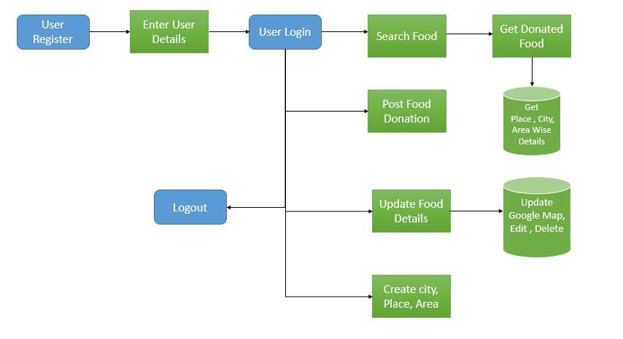

**Fig 3.1 System Architecture**

### 3.2 Uml Diagrams

UML stands for Unified Modeling Language. UML is a language for specifying, visualizing, and documenting the system. This is the step while developing any product after analysis. The goal from this is to produce a model of the entities involved in the project which later need to be built.

### 3.2.1-Use case Diagram

Use case diagrams give a graphic overview of the actors involved in a system, different functions needed by those actors, and how these different functions interact. It9s a great starting point for any project discussion because it helps in easily identifying the main actors involved and the main processes of the system. Use case diagram consists of use cases, actors and shows the interaction between the use case and actors. The purpose is to show the interactions between the use case and actor and to represent the system requirements from the user9s perspective.

**Person/Hotel/**

**Restaurant**

**View food**

**Upload Food Image**

**register**

**login**

**Fig 3.2 Use case Diagram**

**Actor:** An actor in UML specifies a role played by a user or any other system that interacts with the subject.

Actors are:

* User
* Person/Restaurant/Hotel

In the context of a comprehensive system designed to facilitate interactions between users and a food-related platform, the identified use cases play pivotal roles in defining the functionality and user interactions within the system.

The Home Page serves as the initial point of interaction, providing users with a centralized hub to navigate through the application. It acts as a gateway, offering a glimpse into the diverse features and services available within the system.

The Login Page and Registration Page are critical components for user authentication and onboarding. These interfaces ensure secure access to the platform, allowing users to create accounts or log in to existing ones. The seamless and secure login process establishes a foundation for personalized experiences and order tracking.

Once authenticated, users can explore the platform's offerings, exemplified by the View Food Items and Available Food List use cases. These functionalities allow users to peruse a catalog of food items, gaining insights into available options and making informed decisions.

The Book Items and My Order functionalities contribute to the transactional aspect of the system. Users can select desired food items, place orders, and manage their orders efficiently. This includes tracking current orders, viewing order history, and managing delivery details.

The Update Product and Image use case empowers administrators to maintain an up-to-date and visually appealing product catalog. Admins can modify product details and upload images, ensuring that the platform's offerings remain current and enticing to users.

A dedicated View Orders section enables users to track the status of their orders comprehensively. This feature enhances transparency and user satisfaction by providing real-time updates on the progress of their requests.

The Donor Profile and Admin Profile use cases cater to distinct user roles within the system. The Donor Profile allows contributors to manage their profiles, while the Admin Profile provides administrators with the tools to oversee and maintain the overall platform, including user management and system configurations.

**3.2.2 Class Diagram**

Class is nothing but a structure that contains both variables and methods. The class diagram shows a set of classes, interfaces and collaborations, and their relationships. This is the most common diagram in modelling the object-oriented systems and is used to give the static view of a system. The class diagram depicts a static view of an application. It represents the types of objects residing in the system and the relationships between them. A class consists of its objects, and also it may inherit from other classes. A class diagram is used to visualize, describe, document various different aspects of the system, and also construct executable software code.

It shows the attributes, classes, functions, and relationships to give an overview of the software system. It constitutes class names, attributes, and functions in a separate compartment that helps in software development. Since it is a collection of classes, interfaces, associations, collaborations, and constraints, it is termed as a structural diagram.

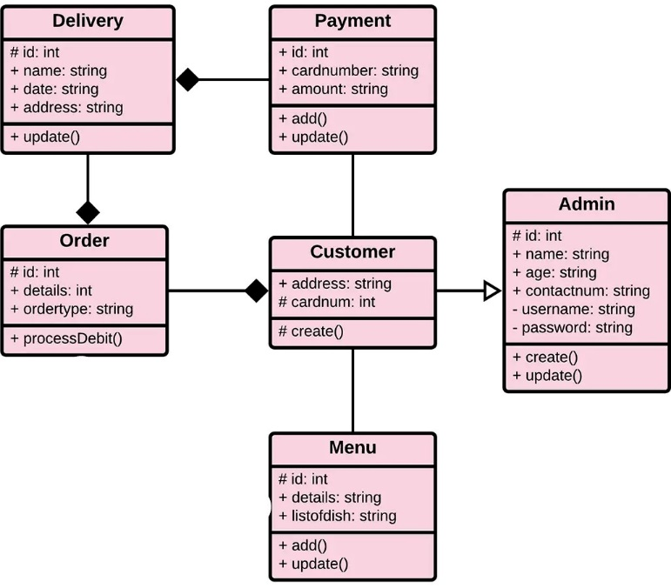

**Fig: 3.3: Class Diagram**

**3.2.3 Activity Diagram**

An activity diagram visually presents a series of actions or flow of control in a system similar to a flowchart or a data flow diagram. Activity diagrams are often used in business process modelling. They can also describe the steps in a use case diagram. Activities modelled can be sequential and concurrent.

An activity diagram in the use-case model illustrates the flow of events of a use case. The flow of events of a use case describes what needs to be done by the system to provide value to an actor. The diagram shows - Activity states, which represent the performance of an activity or step within the flow of events. The categorization of behavior into one or more actions is termed as an activity. In other words, it can be said that an activity is a network of nodes that are connected by edges. The edges depict the flow of execution. It may contain action nodes, control nodes, or object nodes. The control flow of activity is represented by control nodes and object nodes that illustrates the objects used within an activity. The activities are initiated at the initial node and are terminated at the final node. The activity diagram helps in envisioning the workflow from one activity to another. It put emphasis on the condition of flow and the order in which it occurs. The flow can be sequential, branched, or concurrent, and to deal with such kinds of flows, the activity diagram has come up with a fork, join, etc

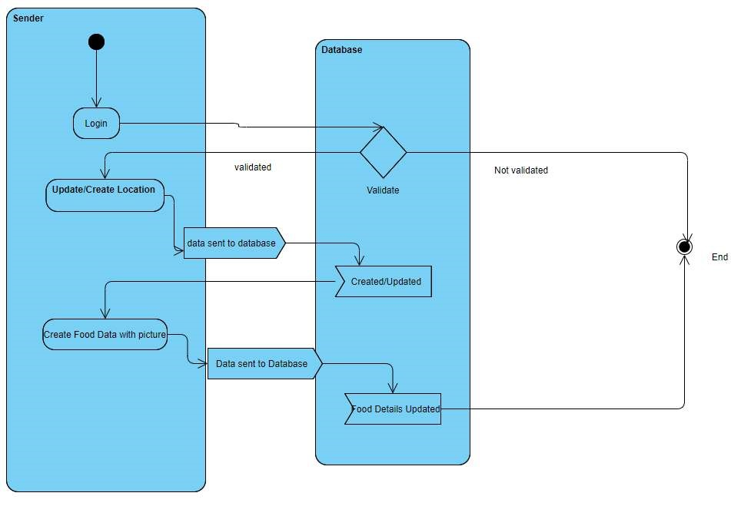

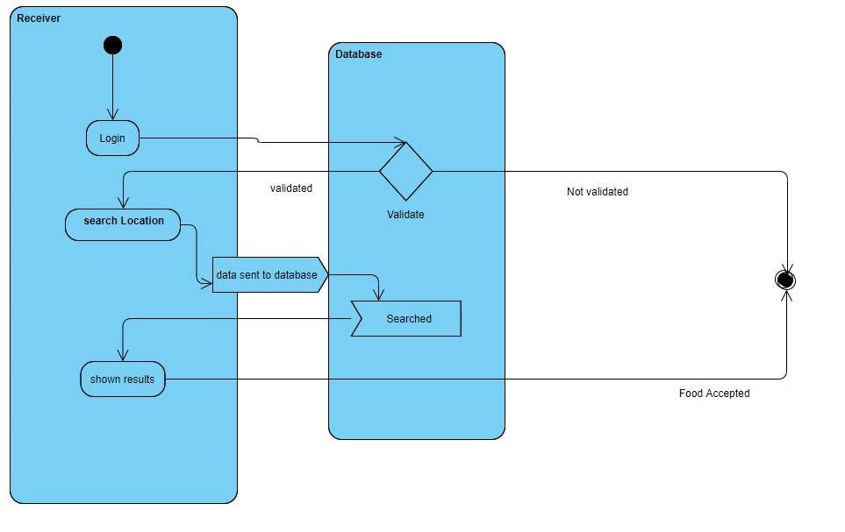

**Fig: 3.4: Activity Diagram**

**3.2.4 Sequence Diagram**

A sequence diagram is an introduction that empathizes the time ordering of messages. Graphically a sequence diagram is a table that shows objects arranged along the X-axis and messages ordered in increasing time along the Y-axis.

User

Person/Hotel/

Restaurant

Database

()

: Register and Login

1

2. Login success or failed

3

: upload food details

()

()

4

: View and book food items

5

: Make Shipping

()

6

: My order

()

**Fig: 3.5 Sequence Diagram**

### *Chapter 4*

### IMPLEMENTATION

### Before diving into the technical aspects, it's crucial to clearly define the goals of your food donation website. Identify the target audience, scope, and functionalities required. Consider collaborating with local food banks, NGOs, or community organizations to understand their needs and incorporate them into your platform.

### Design an intuitive and user-friendly interface to encourage easy navigation. Include a responsive design that adapts to various devices, making it accessible to a broader audience. Prioritize simplicity in the layout to ensure that users can easily locate the necessary information and features.

### Implement a secure user registration and authentication system. Users, both donors and recipients, should be able to create accounts, providing essential details. Utilize secure authentication methods, such as two-factor authentication, to safeguard user accounts and data.

### Create a system for listing available food donations, specifying details such as type of food, quantity, and expiration date. Implement a matching algorithm that connects donors with recipients based on proximity, preferences, and urgency. This ensures a more efficient and timely distribution process.

### Incorporate real-time communication features, such as pop-up window, to facilitate seamless interaction between donors and recipients. This enhances the coordination of food pickups or deliveries and allows for quick responses to inquiries or changes in donation availability.

### Integrate geolocation services and mapping functionalities to enable users to locate nearby food banks, pickup points, or recipients. This feature enhances the overall user experience and streamlines the logistics of food distribution.

### Implement a system that allows donors to track the status of their donations, from confirmation to delivery. Additionally, include reporting tools to generate insights and analytics on the overall impact of the platform, such as the number of meals donated or the communities served.

### If your platform involves financial transactions, integrate a secure payment gateway. This is relevant if you plan to include features like monetary donations or if your platform collaborates with local businesses or sponsors.

### Prioritize the security of user data and transactions. Implement SSL encryption, regularly update security protocols, and conduct thorough testing to identify and address potential vulnerabilities.

### Before launching the food donation website, conduct comprehensive testing to ensure that all features work as intended. Test for usability, performance, and security to deliver a reliable platform to users.

### By carefully considering these aspects during the implementation process, you can create a robust and effective food donation website that serves its purpose in fostering community support and reducing food waste.

### 4.1 Technology Description

The project has been developed using the technologies below:

The development stack for this project incorporates a variety of technologies to ensure a robust and dynamic web application. The foundation of the page layout is crafted using HTML, providing the structural framework for the website. CSS is then employed for all design elements, enhancing the visual appeal and user experience. Bootstrap, a powerful front-end framework, is seamlessly integrated to optimize design components and ensure responsiveness across various devices, contributing to a user-friendly interface.

JavaScript is leveraged to introduce smooth-scroll functionality, enhancing the overall navigation experience on the website. This scripting language plays a crucial role in creating a seamless transition between different sections of the webpage, contributing to an interactive and engaging user interface.

On the server side, PHP is employed to implement both business logic and front-end functionality. This server-side scripting language allows for the dynamic generation of content, facilitating the integration of data and logic to deliver a personalized and efficient user experience. MySQL serves as the database management system, providing a reliable and scalable solution for storing and retrieving data essential for the website's functionality.

To bring the project to life, Xampp is utilized as the server environment. Xampp streamlines the deployment process, allowing the website to run efficiently during development and testing phases. Overall, this comprehensive technology stack ensures a well-rounded and efficient web application, combining front-end aesthetics with robust back-end functionality to create a seamless and effective user experience.

**Internet**

The internet is a massive network of networks. It connects millions of computers globally, forming a network in which any computer can communicate with any other computer as long as they are both connected to the internet.

A website is simply a collection of web pages of codes - codes that describe the layout, format, and content on a page. The web server is an internet-connected computer that receives the request for a web page sent by your browser.

A web browser is a piece of software needed to access the internet and websites. Without a web browser, it is nearly impossible to access websites and the internet. Most data over the internet moves by packet switching, where data is broken up into small pieces called packets that are delivered to their final destination independently. Once there, they are reassembled into content such as text, images, or video on a webpage.

**Intranet**

The classical definition of Intranet is the application of internet technologies to the internal business applications media most refer to the Intranet in terms of applying web technologies to information systems in the organization.

**HTML Introduction**

The Hypertext Markup Language (HTML) is a simple markup language. It was first developed by Tim Berners-Lee in 1990. It is used to create electronic documents (called pages) that are displayed on the World Wide Web. Each page contains a series of connections to other pages called hyperlinks.

Every webpage you see on the internet is written using one version of HTML code or another. Without HTML, a browser would not know how to display text as elements or load images or other elements.

**Why to use HTML?**

HTML is easy to use and understand: Almost anyone in the web development business would know. If at any point in time you need to hire the services of a different web design firm or professional for making changes or updates to your website, it would be relatively easy to find cost-effective and affordable solution providers who can make the changes you need to your website.

All browsers support HTML: Certainly more browsers support HTML than any other web programming language. As a result, when you build a website using HTML, it would show up on most browsers around the world. Optimizing an HTML based website for browser compatibility is neither difficult nor complex.

Most development tools support HTML: For a front-page we can use HTML, and we can use development tools like python, java, and so on in the backend. Many of the development tools support HTML.

HTML is the most search engine friendly: <SEO= refers to search engine optimization or the process of optimizing a website so that people can easily find it via search engines like Google. Of all the web programming languages, HTML is the most search engine friendly. Creating SEO compliant websites using HTML is significantly easier than any other programming language.

**Structure of HTML:**

HTML elements perform a defined task. HTML uses two types of elements

Empty Tags: Empty tags represent formatting constricts such as line breaks and horizontal rules. E.g.: <tag name>

Container Tags: Container tags define a section of text, formats, and dot all of the selected text. A container tag has both a beginning and an ending.

E.g. :

<tag name> content </tag name>

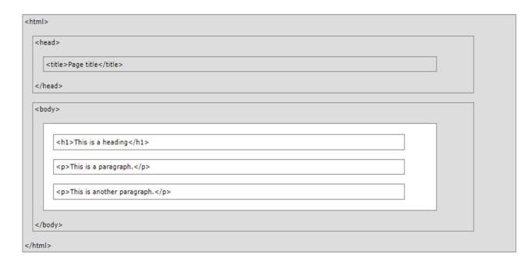

**Fig: 4.1: HTML page structure**

**CSS**

CSS stands for 8Cascading Style Sheets9.CSS is used to format the layout of web pages.

While HTML is used to structure a web document (defining things like headlines and paragraphs, and allowing you to embed images, video, and other media), CSS comes through and specifies your document style – page layouts, colors, and fonts are all determined with CSS.

CSS describes how HTML elements are to be displayed on a screen, paper, or in other media. CSS saves a lot of work. It can control the layout of multiple web pages all at once. It is also used to define styles for the web pages, including the design, layout, and variations in display for different devices and screen sizes.

**Bootstrap**

Bootstrap is the most popular CSS framework for developing responsive and mobile-first websites. It includes HTML and CSS based design templates for typography, forms, buttons, tables, navigation, modals, image carousels, etc ... Some additional reasons to use Bootstrap is its responsive CSS adjusts to phones, tablets, and desktops.

Bootstrap 4 is the newest version of Bootstrap. It supports all major browsers except Internet Explorer 9. But Bootstrap 3 is supported in all browsers.

Here we have used Bootstrap CDN to deliver content from application to people more quickly and efficiently. Bootstrap CDN is a public content delivery network. It enables users to load CSS, JavaScript, and images remotely from its servers.

**JavaScript**

JavaScript is most used as a client-side scripting language. When a user requests an HTML page with JS in it, the script is sent to the browser and it9s up to the browser to do something with it.

In this website, we have used JS for enabling smooth-scroll in the web page. The smooth scrolling component is used to animate the browser scrolling when a user clicks an element linking to a different section on the same page.

**PHP**

PHP stands for Hypertext Pre-processor, which earlier stood for Personal Home Pages. It is a server-side scripting language that is embedded in HTML. It is used to manage dynamic content, databases, session tracking, even build entire e-commerce sites. It is integrated with several popular databases, including MySQL, PostgreSQL, Oracle, Sybase, Microsoft SQL Server, etc.

We have used PHP to store the data that is entered on the web page in a database through programming in PHP. Data can be fetched from MySQL tables by executing SQL statements which can be also called 8queries9 through writing a program in PHP.

**My SQL – Database**

A database is a collection of information that is organized so that it can be easily accessed, managed, and updated. Like a data file, a database does not present information directly to a user; the user runs an application that accesses data from the database and presents it to the user in an understandable format.

A database typically has two components: the files holding the physical database and the database management system (DBMS) software that applications use to access data. The DBMS is responsible for enforcing the database structure, including:

* Maintaining the relationship between data in the database.
* Ensuring that data is stored correctly and that the rules defining data relationships are not violated.
* Recovering all data to a point of known consistency in case of system failures.

In this project, we have used the MySQL database. It is a freely available open source Relational Database Management System (RDBMS) that uses Structured Query Language (SQL). SQL is the most popular language for adding, accessing, and managing content in a database.

MySQL creates a database for storing and manipulating data, defining the relationship of each table. Clients can make requests by typing specific SQL statements on MySQL. The server application will respond with the requested information and it will appear on the clients' side.

**XAMPP – Server**

The full form of XAMPP is X stands for Cross-platform, (A) Apache server, (M) MariaDB, (P) PHP, and (P) Perl. The Cross-platform usually means that it can run on any computer with any operating system.

It is open-source software developed by Apache Friends. It is localhost or a local server. This local server can work on a desktop or laptop computer. The use of XAMPP is to test the clients or website before uploading it to the remote web server. This XAMPP server software gives you a suitable environment for testing MYSQL, PHP, Apache, and Perl projects on the local computer.

At its core, XAMPP integrates Apache as the web server, MariaDB (a MySQL fork) as the database management system, PHP as the server-side scripting language, and Perl for scripting purposes. This combination creates a versatile and comprehensive stack that caters to both beginners and experienced developers.

One of the key advantages of XAMPP is its ease of installation and configuration, making it accessible to users across different operating systems, including Windows, macOS, and Linux. This local server environment ensures that developers can replicate the server conditions on their own machines, allowing for efficient testing and debugging of web applications before they go live.

XAMPP also simplifies the setup of additional components, such as phpMyAdmin for database management and FileZilla for FTP services. This integrated approach streamlines the web development process, providing a centralized platform for managing various aspects of web application development.

At its core, XAMPP integrates Apache as the web server, MariaDB (a MySQL fork) as the database management system, PHP as the server-side scripting language, and Perl for scripting purposes. This combination creates a versatile and comprehensive stack that caters to both beginners and experienced developers. This integrated approach streamlines the web development process, providing a centralized platform for managing various aspects of web application development.

### 4.2 Installation Steps

### To begin the process of accessing our website dedicated to food donation, the first step is to open the designated URL in a web browser. This URL serves as the unique address that directs users to our online platform. Once the web browser is open, enter the URL into the address bar and press enter, initiating the connection to our website.

### Following the successful opening of the URL, the next step involves conducting a search for our specific website focused on food donation. This can be done by utilizing the search functionality within the website or employing a search engine if necessary. Enter relevant keywords such as "food donation" to narrow down the results and locate our website amidst the online landscape.

### Upon identifying the correct search result corresponding to our food donation website, proceed to open it by clicking on the link or selecting the appropriate option provided. This action directs users to the homepage or landing page of our website, where they can explore information, resources, and opportunities related to food donation. By following these steps, users can seamlessly navigate to our online platform and engage with the content and features tailored to facilitate and promote food donation initiatives.

### 4.3 Procedure For Execution

To establish a local server environment for PHP files, XAMPP can be employed to facilitate the loading of PHP files into a web browser. This ensures a seamless testing and development process for web applications. Once the XAMPP server is started, users can open the index.html file, which serves as the homepage of the web application.

Upon accessing the homepage, users are prompted to register, allowing them to choose between becoming a sender or receiver for food-related activities. This registration step is essential for creating distinct user profiles and facilitating personalized interactions within the system. Subsequently, users need to log in to access their respective accounts, enabling them to manage and perform actions such as donating or receiving food. After successfully logging in, users are presented with a range of options tailored to their role and preferences. These options include the ability to search for available food based on location, update food details if they are a sender, review the history or status of their orders, create a new city for enhanced search availability, establish specific spots within cities, donate food to those in need, and view the contents of their shopping cart, providing insight into any ongoing or pending orders.

By structuring the user interface in this manner, the web application ensures a user-friendly and intuitive experience, empowering individuals to contribute to the community by either donating surplus food or receiving assistance when in need. The systematic categorization of features streamlines user interactions and enhances the overall functionality of the platform.

**4.4 Project Snapshots:**

This page is the Main (Home) page of Food Donation Website. This page offers the following links:

1. Home Page
2. About Us Page
3. Available Food List Page
4. Contact Us Page
5. Donor Page
6. Admin Page
7. Our Campaign Page

**4.4.1 Home Page**

The home page acts as the gateway to our web application. New users can quickly register as senders or receivers, while returning users can log in securely to access their personalized dashboards. This central hub allows users to manage orders, update food details (for senders), and explore various features. The intuitive navigation menu facilitates easy access to key functions, including searching for food, updating details, and viewing order history. With a focus on simplicity, our home page ensures an efficient and engaging user experience.

This central hub allows users to manage orders, update food details (for senders), and explore various features. The intuitive navigation menu facilitates easy access to key functions, including searching for food, updating details, and viewing order history. With a focus on simplicity, our home page ensures an efficient and engaging user experience.

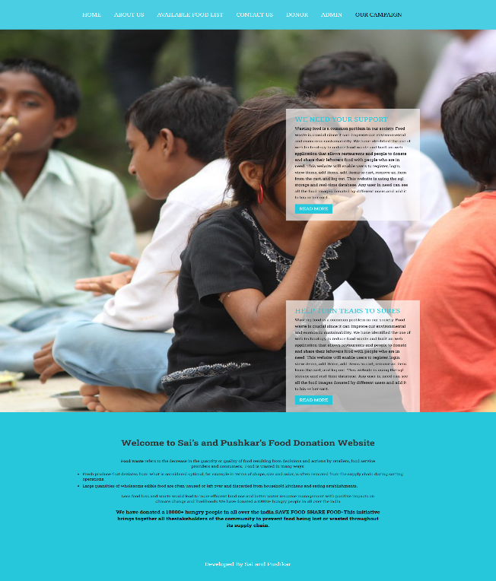

**4.1 Home Page**

**4.4.2 About Us Page:**

In this page, users can view about page, in that user can see the more information about our website. All the information related to developers and the website is available here at this page.

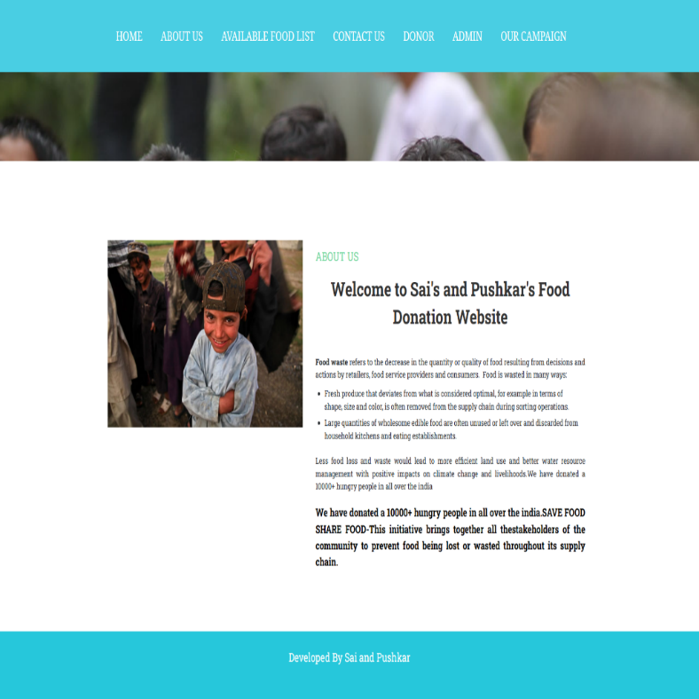

**Fig: 4.2: About Us Page**

**4.4.3 Available Food List:**

In this page users can view Available Food List. This page is for viewers to see available food list for those who needs the food. They can choose the specific food list button for more details. In that they can request for the food and after that they have to enter their details like address, city, contact number and message box for adding the necessary message.

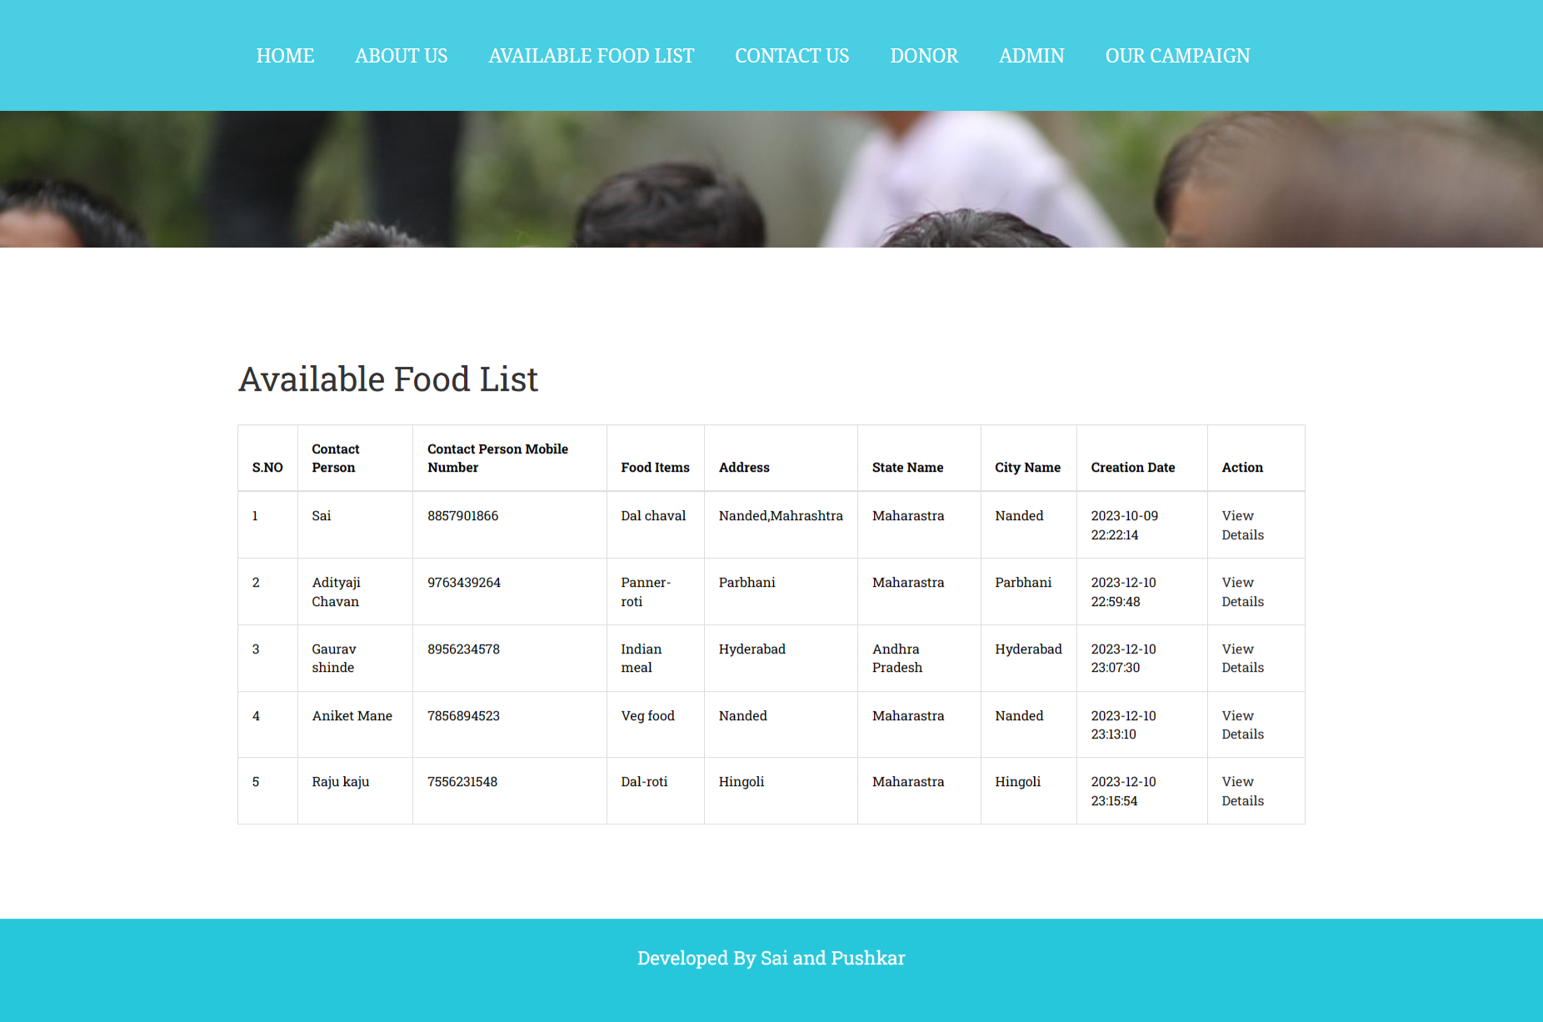

**Fig: 4.3: Available Food List**

* + 1. **Contact us page:**

In this Contact us page, users can view our website contact details in that user can contact us for their queries and also they can work with us if interested by filling the form .In that they have to fill name, phone number, email and more.

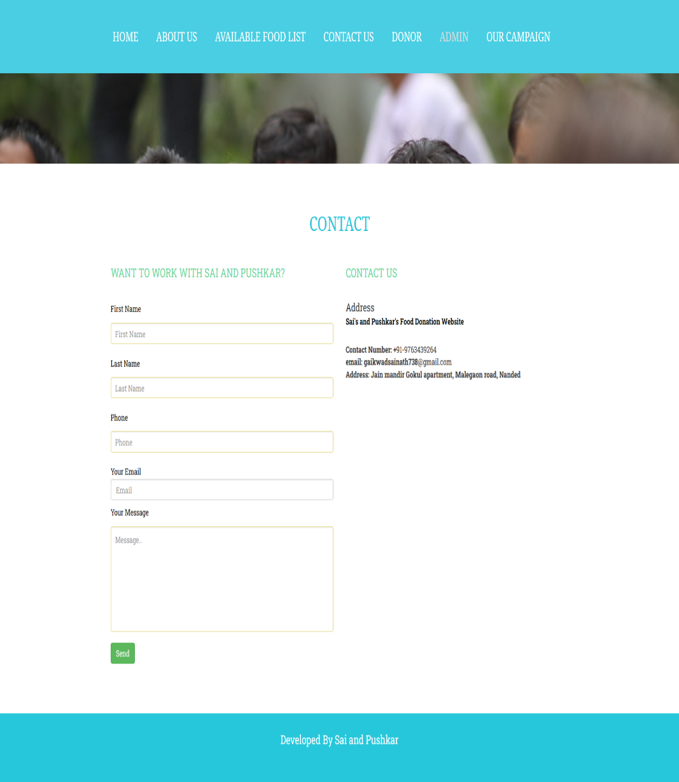

**Fig: 4.4: Contact us Page**

**4.4.5 Donor page:**

If user wants to donate the food they can donate the food by logging in and then by adding the food details. Donor can edit the food details and delete the food details and more buttons are there for editing the food details.

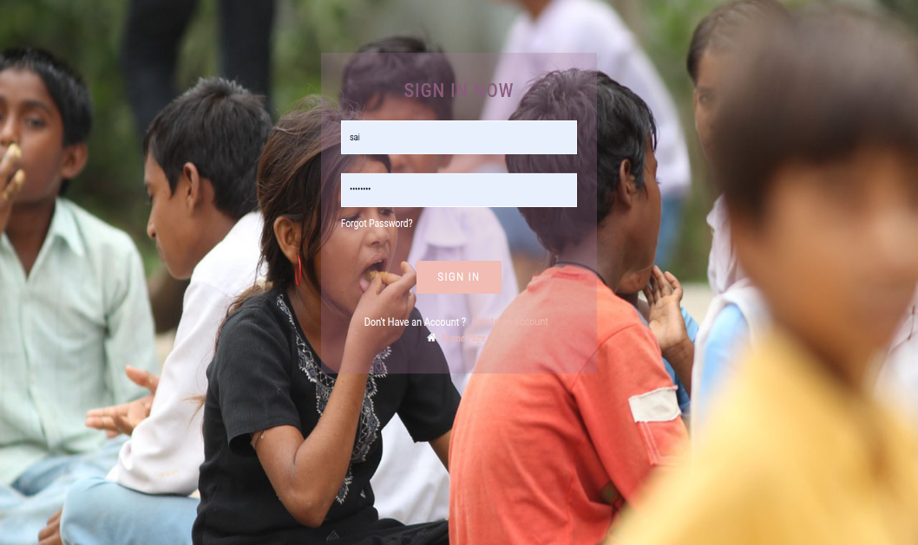

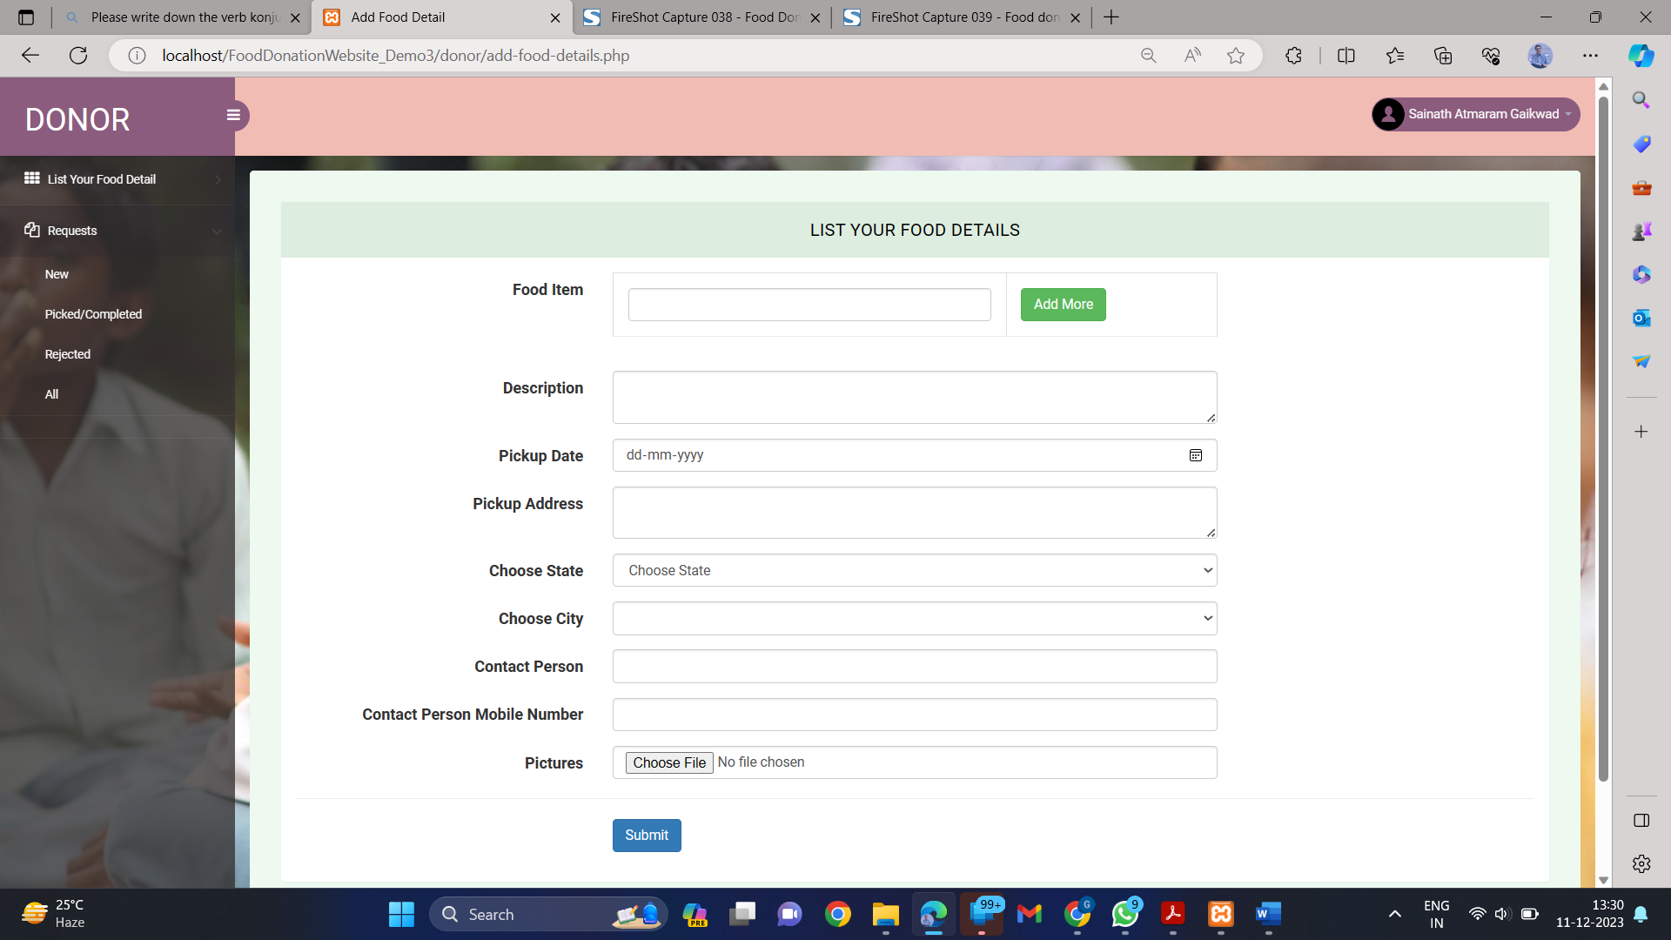

**Fig: 4.5: Donor Page**

**4.4.6 Admin page:**

Admin can login to view the all the details related to donor, receiver, rejected food list.

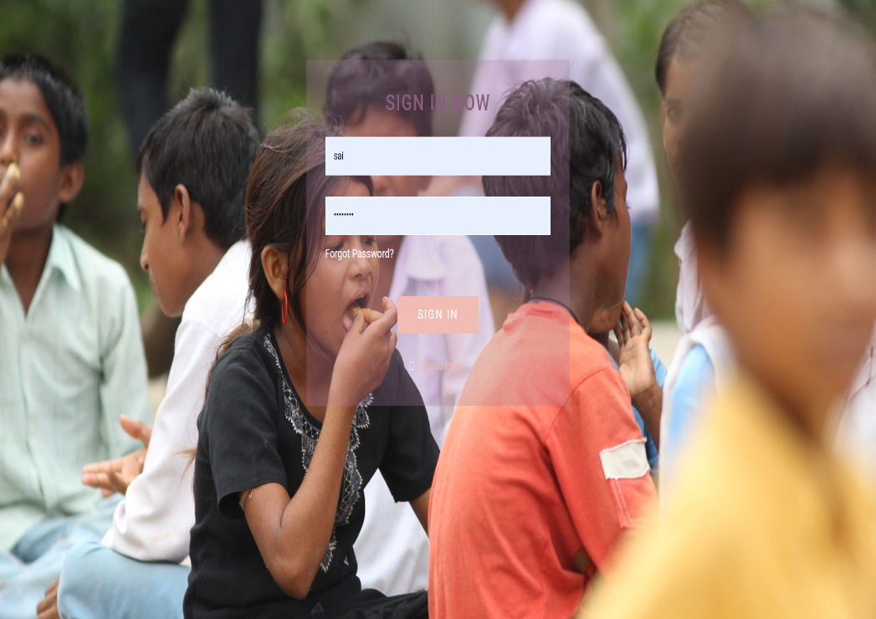

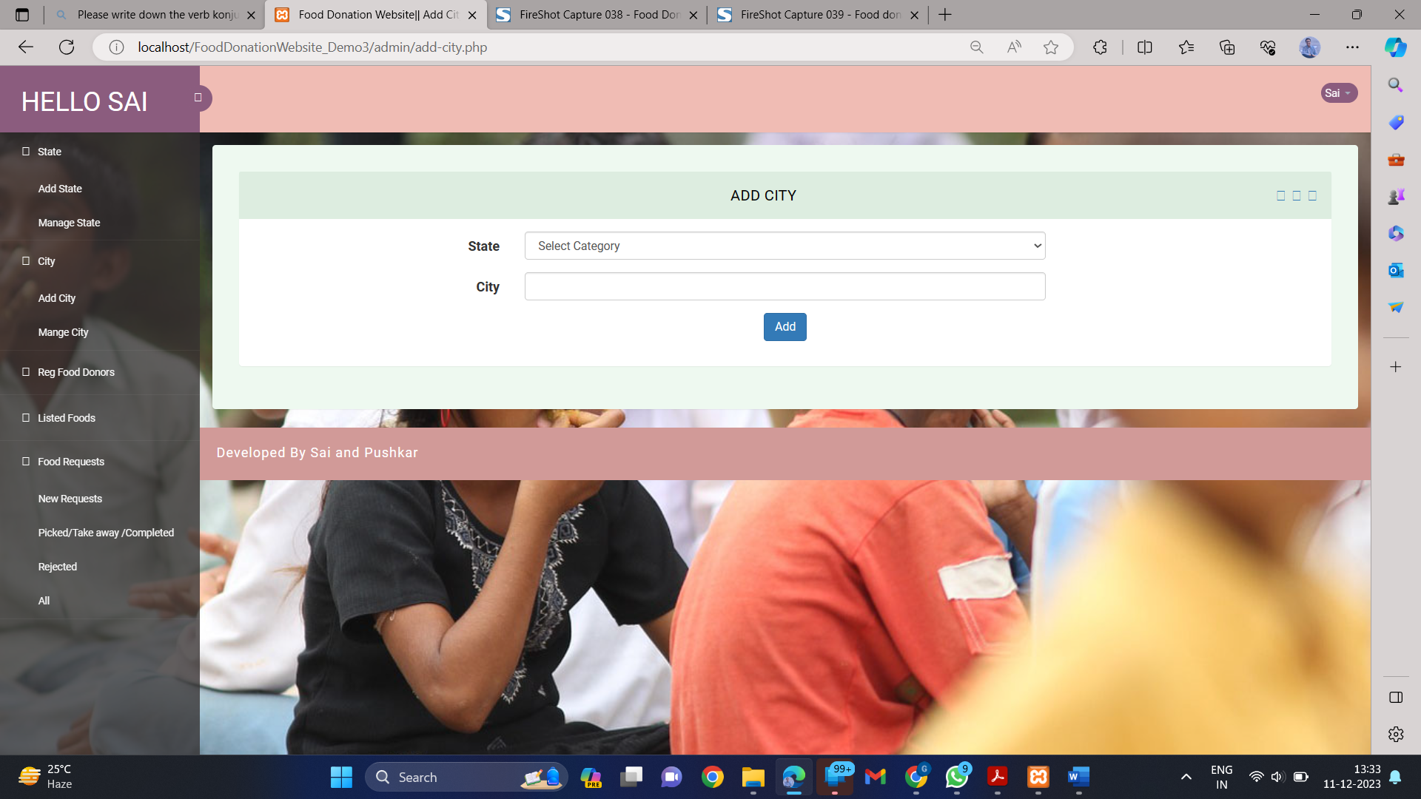

**Fig: 4.6: Admin Page**

**4.4.7 Our Campaign page:**

This page shows campaigns which are till now and will be carried in future. All the details related to the campaigns are listed here.

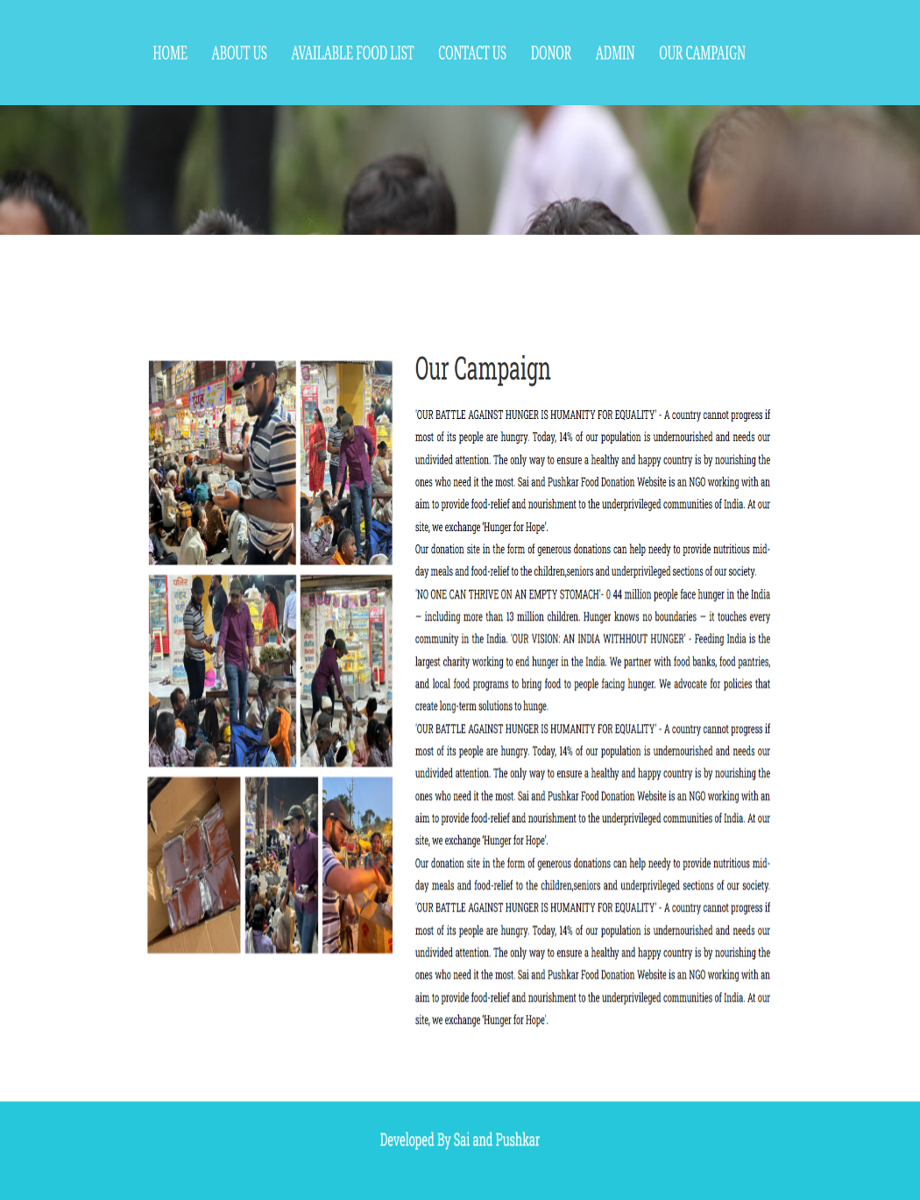

**Fig: 4.7: Donor Page**

***Chapter 5***

**TESTING**

Testing is a crucial phase in the development of any website, especially when it comes to platforms dedicated to food donation. The effectiveness and reliability of a food donation website are paramount to ensure a seamless experience for both donors and recipients. In order to conduct comprehensive testing, several key areas need to be considered.

First and foremost, functionality testing is essential to verify that all features of the website are working as intended. This includes testing the registration process for both donors and recipients, ensuring that users can easily navigate through the platform, and confirming that the donation submission process is straightforward and secure. Any issues related to broken links, form submissions, or error messages must be identified and addressed.

Usability testing is equally important in evaluating the user experience. This involves assessing the website's layout, design, and overall user interface to ensure it is intuitive and user-friendly. Donors and recipients should be able to navigate the site effortlessly, and the donation process should be streamlined to encourage participation.

Security testing is a critical aspect to safeguard sensitive information and maintain user trust. This involves checking for vulnerabilities in the website's code, database, and overall infrastructure. Payment transactions, if applicable, should be secure, and user data must be protected to prevent unauthorized access.

Compatibility testing ensures that the website functions optimally across various devices and browsers. This includes testing on different web browsers, operating systems, and mobile devices to guarantee a consistent and reliable experience for users regardless of their chosen platform.

Performance testing assesses the website's responsiveness, speed, and overall performance under different conditions, such as varying levels of user traffic. This is crucial to identify and address any potential bottlenecks or issues that may arise when the website experiences high levels of activity.

In addition to these technical aspects, it is essential to conduct end-to-end testing to simulate real-world scenarios and ensure the entire donation process, from registration to delivery, is seamlessly executed. This involves testing the website's communication with external systems, such as email notifications and mapping services.

Regular updates and maintenance are essential for the ongoing success of a food donation website. Once testing is completed, continuous monitoring and periodic testing are necessary to address any emerging issues and improve the overall functionality and user experience of the platform.

**5.1 Software Testing Techniques:**

Software testing is a critical element of software quality assurance and represents the ultimate review of specification, designing and coding.

**5.2 Testing Objectives:**

Testing is a crucial phase in the software development life cycle, aiming to ensure the reliability and quality of a software product. The process involves the systematic execution of a program with the primary goal of identifying errors or defects that may compromise the functionality, security, or performance of the software. By intentionally subjecting the software to various scenarios, testing helps uncover issues that may not be apparent during the development phase.

A fundamental principle in test case design is the creation of scenarios with a high probability of revealing previously undiscovered errors. This approach requires a thoughtful consideration of different inputs, conditions, and execution paths to ensure comprehensive coverage.

Success in testing is defined by the ability to uncover undiscovered errors. A successful test not only identifies defects but also provides valuable insights into the nature and impact of these errors.

However, it's important to recognize the limitations of testing. Despite its critical role, testing cannot guarantee the absence of defects in software. The absence of errors in a test does not imply a defect-free software; it merely suggests that the specific conditions and scenarios tested did not reveal any issues. Testing is a dynamic process, and as software evolves, new defects may emerge, underscoring the continuous need for testing throughout the development life cycle.

There are various testing strategies employed to address different aspects of software quality.

**5.2.1 Unit Testing:**

Unit testing focuses verification efforts on the smallest unit of software design module. The unit test is always white box oriented. The tests that occur as part of unit testing are testing the module interface, examining the local data structures, testing the boundary conditions, execution all the independent paths and testing error-handling paths.

* + 1. **Integration Testing:**

Integration testing is a systematic technique or construction the program structure while at the same time conducting tests to uncover errors associated with interfacing. Scope of testing summarizes the specific functional, performance, and internal design characteristics that are to be tested. It employs top-down testing and bottom-up testing methods for this case.

* + 1. **Performance Testing:**

Timing for both read and update transactions should be gathered to determine whether system functions are being performed in an acceptable timeframe.

**5.2.4 Functional Testing:**

Objective: Test the application's features and functionalities against the defined requirements.

Tools: Selenium, Cypress, or TestCafe for simulating user interactions.

**5.2.5 Cross-Browser Testing:**

Objective: Ensure the portal functions correctly on various web browsers (Chrome, Firefox, Safari, Edge, etc.).

Tools: BrowserStack, CrossBrowserTesting, or using the browsers manually.

**5.2.6 Responsive Design Testing:**

Objective: Verify that the portal is responsive and works well on different devices and screen sizes.

Tools: Browser developer tools, online emulators, or testing on physical devices.

**5.2.7 Security Testing:**

Objective: Identify and fix vulnerabilities to ensure the portal is secure.

Tools: OWASP ZAP, Burp Suite, or specialized security testing services.

User Acceptance Testing (UAT):

Objective: Obtain feedback from actual users to ensure the portal meets their needs.

Tools: Conduct manual testing with real users and gather feedback.

**5.2.8 Accessibility Testing:**

Objective: Ensure the portal is accessible to users with disabilities.

Tools: Lighthouse, AXE, or manual testing using screen readers and keyboard navigation.

**5.2.9 Database Testing:**

Objective: Verify that data is stored, retrieved, and updated correctly in the database.

Tools: SQL queries, database testing frameworks.

**5.2.10 Error Handling Testing:**

Objective: Ensure the portal handles errors gracefully and provides meaningful error messages to users.

Tools: Manual testing and automated tests for error scenarios.

**5.2.11 Load Testing:**

Objective: Evaluate the portal's performance under expected and peak loads.

Tools: Apache JMeter, LoadRunner, or tools provided by cloud services.

**5.2.12 Compatibility Testing:**

Objective: Ensure the portal works well with different operating systems and configurations.

Tools: Test on various OS versions and configurations.

**5.2.13 Usability Testing:**

Objective: Evaluate the portal's overall user experience, navigation, and intuitiveness.

Tools: Usability testing tools or user feedback.

Objective: Verify that all documentation, including user guides and technical documentation, is accurate and up-to-date.

Tools: Manual review of documentation.

**CONCLUSION**

In conclusion, our study delved into the pressing issue of food waste, shedding light on its significant economic and social repercussions. Recognizing the multifaceted nature of the problem, we explored potential solutions, highlighting the pivotal roles of political regulations and technological advancements. One such technological avenue is the use of web applications, which can play a crucial role in mitigating food wastes.

Our focus on web application technology as a means of facilitating food donation represents a proactive approach to addressing this challenge. By leveraging the power of the internet, our proposed solution aims to foster a culture of better food donation practices. Specifically tailored to the context of the community, the website serves as a platform to encourage and streamline the process of sharing surplus food resources.

We acknowledge that this work serves as an initial step towards the larger goal of designing a comprehensive system to combat daily food waste. The collaborative efforts of policymakers, technologists, and the community are essential in implementing and sustaining such solutions. By combining political will with innovative technologies, we can work towards building a more sustainable and efficient system that not only reduces food wastage but also fosters a sense of responsibility and community engagement. Through initiatives like these, we aspire to contribute to a more conscientious and sustainable future, where the impact of food waste is significantly diminished.

**REFERENCES**

[1] Thamilini, J., Silva, K.D.R.R. and Jayasinghe, J.M.U.K., 2015. Prevalence of stunting among pre-school children in food insecure rural households in Sri Lanka. Tropical Agricultural Research, 26(2)

https://papers.ssrn.com/sol3/papers.cfm?abstract_id=3743633

[2] N. Alblihed, M. Almutairi, R. Almahmoud, S. Aladhadh and A. Alabdulatif, "Developing Food Charity Operations Management System," 2022 2nd International Conference on Computing and Information Technology (ICCIT), Tabuk, Saudi Arabia, 2022, pp. 93-96, doi: 10.1109/ICCIT52419.2022.9711609.

https://ieeexplore.ieee.org/document/9711609

[3] Lowrey, John and Richards, Timothy J. and Hamilton, Stephen F., Food Bank Donations and Retail Pricing (December 6, 2020)

https://papers.ssrn.com/sol3/papers.cfm?abstract_id=3743633

[4] VLAHOLIAS, Elisha, et al. Charity starts… at work? Conceptual foundations for research with businesses that donate to food redistribution organisations. Sustainability, 2015, 7.6: 7997-8021.

https://www.mdpi.com/2071-1050/7/6/7997

[5] Nan Ye, Lefa Teng, Ying Yu, Yingyuan Wang,“What's in it for me?”: The effect of donation outcomes on donation behavior,Journal of Business Research,Volume 68,Issue 3,2015,Pages 480-486,ISSN 0148- 2963,https://doi.org/10.1016/j.jbusres.2014.09.015

https://www.sciencedirect.com/science/article/abs/pii/S0148296314002987